**CMPSC 462 – Lab-3** (25 points)

**Stack and Queue**

**Due date: 2/8/2022**

**Note:** attach screenshots of your program and results under each programming exercises. Please make sure that the screenshot is readable. Don’t attach a very small screenshot image.

**Lab Exercises:**

1. Write a program that reads in a sequence of characters and prints them in reverse order. Use a stack. Try “Madam, I'm Adam”, “racecar”.

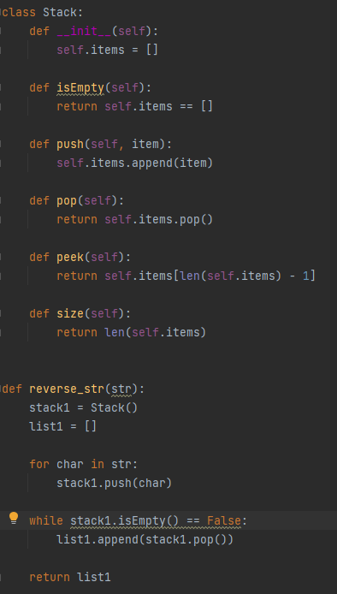

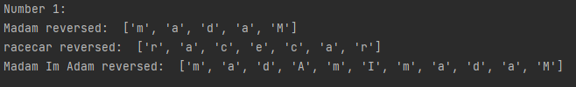

1. Show how to implement a Queue using two stacks?

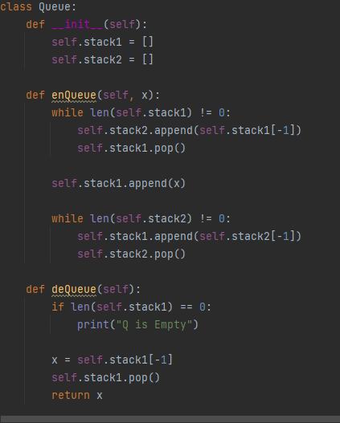

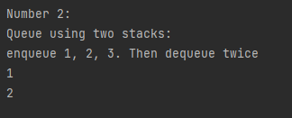

1. Assume that you are not as careful programmer as you are and you frequently forget to close your brackets while you program - (, {, [ . You find it difficult to find where the mistake is. Write a program that reads in a sequence of characters, and determines whether its parentheses, braces, and curly braces are "balanced." Hint: for left delimiters, push onto stack; for right delimiters, pop from stack and check whether popped element matches right delimiter.

